CHAPTER 5

TOPIC OBJECTIVES



· Using Explain Plan

· Optimizer Rules

· Tuning SQL Statements

EXPLAIN PLAN

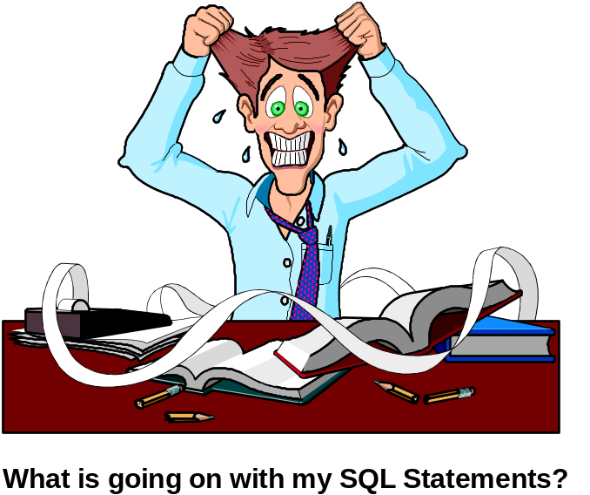

The EXPLAIN PLAN diagnostic tool allows you to observe how ORACLE executes
SQL statements. The EXPLAIN PLAN statement displays the execution plan
selected by the OPTIMIZER for SELECT, INSERT, UPDATE, and DELETE
statements. Before you can use this performance diagnostic tool you must:

• Create a plan table

• Understand what information the optimizer will load into this table

• Be able to maintain and synchronize the rows in the plan table

THE PLAN_TABLE COLUMNS(2)


Three new columns to use

There are new columns in the PLAN-TABLE that help estimate resource cost of statements.

- CPU_COST - This column holds numbers that represent the CPU cost of the statement. This column will be NULL if the rule-based optimizer is used.

- IO_COST - This column holds numbers that represent the disk I/O of the statement. This column will be NULL if the rule-based optimizer is used.

- TEMP_SPACE - This column holds numbers that represent the size, in bytes, of any temporary space the statements might require. If the rule-based optimizer is used or if the statement does not require any temporary space, this column will be NULL.

To use these columns make sure you have generated statistics on the schema objects you are evaluating.
EXPLAIN PLAN SYNTAX



When using EXPLAIN PLAN, the actual SQL statement is not executed.
Instead, a plan tree is inserted into the PLAN_TABLE. A query must then
be written against the PLAN_TABLE to interpret the results.

The identification and informational columns of the PLAN_TABLE are:

COLUMN DESCRIPTION

STMT DESCRIPTION A description of the statement
TABLE_NAME The table in which the output from EXPLAIN PLAN is
stored. The default is PLAN_TABLE.
STATEMENT_ID The statement description
TIMESTAMP The date and time EXPLAIN PLAN was executed.
REMARKS Comments about the EXPLAIN results.
OPERATION The operation performed in this step.
OPTIONS Options about the operation.
OBJECT_NODE The database link used to reference an object.
OBJECT_OWNER The user that owns the table or view
OBJECT_NAME Database, table, or index name
OBJECT_INSTANCE The position of the object as it occurred in the statement.
Numbering is from left to right, outer to inner. View
expansion results in unpredictable numbers.
OBJECT_TYPE Description of the object
SEARCH_COLUMNS Not currently used.
ID The user assigned id number for this statement and run
PARENT_ID The id of the next execution step that operates on the
output of the ID step
POSITION Order of processing for steps have the same
PARENT_ID
COST Places a COST NUMBER in this column if the
cost-based optimizer was used.
OTHER Other information for this run, such as the query for
remote node execution.

OPERATIONS IDENTIFIED BY THE EXPLAIN PLAN

Operations column of the Description
PLAN_TABLE

SELECT STATEMENT
UPDATE STATEMENT
DELETE STATEMENT
INSERT STATEMENT
AND-EQUAL Used for WHERE clause equalities. Each
comparison includes a non-unique indexed
column from which ROWIDs are obtained
and intersected. Indexes are “MERGED”.
CONNECT BY Retrieval based on a tree-walk
CONCATENATION UNION ALL for a group of tables (ORs rule)
COUNT A count operation
FILTER A restriction of the rows returned
FIRST ROW A retrieval of only the first row of a query
FOR UPDATE A retrieval that row locks on selected rows
INDEX A retrieval from an index
Options:
UNIQUE SCAN index search for unique values
RANGE SCAN index search for range between
INTERSECTION A retrieval of rows common to two tables.
The tables are sorted first.
MERGE JOIN A join formed by merging two sorted sets of data
Options:
OUTER -- an outer join
MINUS -- a retrieval of rows in table 1 but not
in table 2
NESTED LOOPS A join on two child operations (each row returned
by the first child operation is then operated on by
the second child operation). One of three methods
used to join tables. The other two are SORT
MERGE and INDEX CLUSTER
PROJECTION Selecting a subset of the columns
REMOTE Retrieval across SQL*NET
SEQUENCE An operation involving the sequence generator
SORT A retrieval of rows ordered by one or more columns
SORT UNIQUE UNIQUE -- sort to produce unique values
SORT GROUP BY GROUP BY -- sort for grouping
SORT JOIN JOIN -- sort for merge join
SORT ORDER BY ORDER BY -- sort for order by

EXPLAIN PLAN TABLE COLUMNS

Operations Column of the Description
PLAN_TABLE

TABLE ACCESS A retrieval from a base table
TABLE ACCESS BY ROWID BY ROWID table access by ROWID
TABLE ACCESS FULL FULL able access by Full Table Scan
CLUSTER table access by Cluster key
UNION A retrieval of unique rows from two tables
UNIONed together dropping the duplicates
VIEW A retrieval from a view of a table
OPTIMIZER Choose, RULE, FIRST ROWS, ALL_ROWS

In order to load the PLAN_TABLE with rows concerning a particular SQL statement
you would execute the following SQL: Review and execute the scripts big2.sql and
big3.sql in order to run the following explain plan selects. ORACLE> @big2 @big3

EXPLAIN PLAN
[SET STATEMENT_ID = ‘STMT DESCRIPTION’]
[INTO table_name]
FOR SQL_STATEMENT;

EXAMPLES:

SQL> EXPLAIN PLAN FOR
SELECT *
FROM BIG2
WHERE BIGNO NOT BETWEEN 1 AND 4955;

To see the plan results you would execute dbms_xplan(display)

PLAN_TREE ANALYSIS

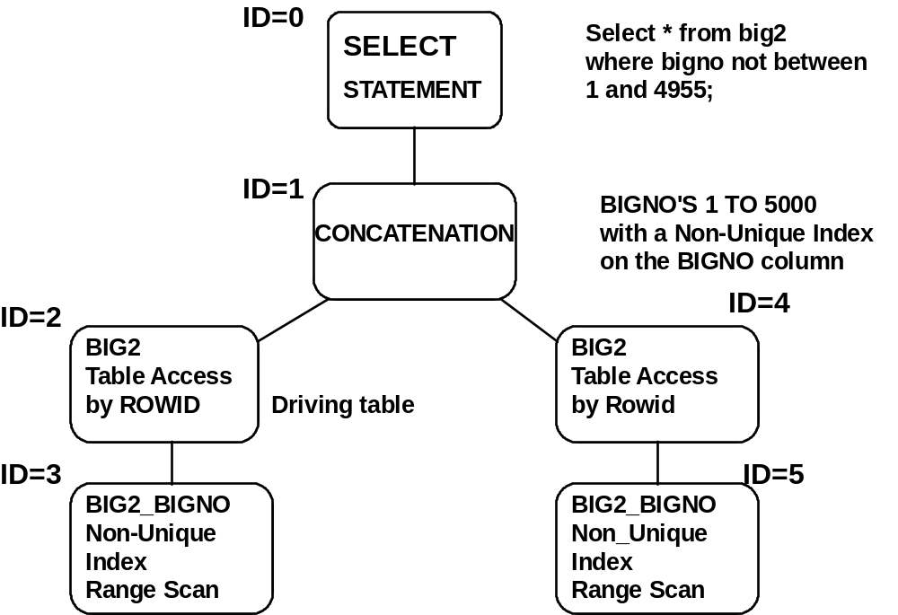

select id, parent_id,object_name,object_type,operation,options
from plan_table order by id; OR
SELECT * FROM TABLE(DBMS_XPLAN.DISPLAY)

COL OBJECT_NAME FORMAT A12
COL OBJECT_TYPE FORMAT A12
COL OPERATION FORMAT A12
COL OPTIONS FORMAT A12

ID PARENT_ID OBJECT_NAME OBJECT_TYPE OPERATION OPTIONS
--- ----------------- ----------------------- ------------------- ------------------- --------------
0 Select statement
1 0 Concatenation
2 1 BIG2 Table Access By ROWID
3 2 BIG2_BIGNO Non-Unique Index RangeScan
4 1 BIG2 Table Access By ROWID
5 4 BIG2_BIGNO Non-Unique Index RangeScan

NESTED OUTPUT USING “START WITH” AND “CONNECT BY”

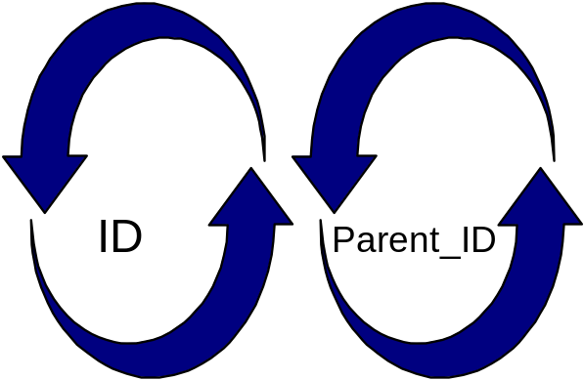
ORACLE> COL “Query Plan” format a80

ORACLE> select LPAD (‘ ‘, 2*(LEVEL-1)) ||
OPERATION || ‘ ‘ ||
OPTIONS || ‘ ‘ ||
OBJECT_NAME || ‘ ‘ ||
DECODE (ID, 0, ‘COST = ‘ || POSITION)
“ Query Plan”
from PLAN_TABLE
START WITH ID = 0
CONNECT BY PRIOR ID = PARENT_ID;

See explain.sql or the dbms_xplan command seeing the above code.
Query Plan
-------------------------------------------------------------------------------------------------------------
Select Statement COST=1
Concatenation
Table access by ROWID BIG2
Index Range Scan Big2_BIGNO
Table access by ROWID BIG2
Index Range Scan BIG2_BIGNO

Read the output from the Explain Plan query by reading from the inside out and top bottom in a clockwise fashion.
- First, read the most indented clauses. If there is a tie, read from the top to the bottom

EXPLAIN PLAN OPERATION DEFINITIONS

Operation Option Definition
TABLE
ACCESS FULL FULL TABLE SCAN - one row is read at a time
until all rows are read.
CLUSTER Table scan on an Index Cluster Table Key
HASH A Hash Key is matched against a matching Hash
value
BY ROWID Accesses a row by its ROWID usually from an Index
UNIQUE SCAN A single row is returned from a unique index
FULL A full scan of the index is performed. Because the index
is in sorted order. It should be better than a full table scan and sort.
FAST FULL The rows do not have to be returned in sorted order.
Utilizes multiblock I/O and can be run in parallel. All
the blocks of the index are scanned
RANGE SCAN A range of values is returned from an index. Used
with operators like <>, LIKE% or _, or BETWEEN.
RANGE SCAN desc A range scan in descending order
AND EQUAL Up to fine indexes can be merged. Each index is
processed with the results merged with the results of
another index.
UNION ALL A set operation used for UNION ALL. Returns all rows
from both queries. Does not eliminate duplicates or sort.
VIEW A VIEW is a SET operation. A view will be evaluated
and processed first, then merged with the rest of the query
HASH JOIN One of the tables has in memory a bitmap created and a hashing function is used to find the matching rows in the second table.
MERGE JOIN Tables are sorted and then merged
NESTED LOOPS One of the tables is read one row at a time and a match is produced by accessing the second table. Usually, the second table has an index.
OUTER JOIN With an OUTER JOIN, one of the tables is a complete table. All rows from that table will be returned regardless if there is a match. Performs a FULL TABLE SCAN.
SEQUENCE when the NEXTVAL or CURRVAL is processed against a sequence number.

EXPLAIN PLAN OPERATIONS DEFINITIONS - PART 2

Operation Option Definition
SORT Used with aggregate functions such as SUM, MIN, AGGREGATE MAX, COUNT, and AVG
SORT ORDER BY Used to sort rows with the ORDER BY clause
CONCATENATION A row operation that will combine the results of an
IN clause.
FOR UPDATE places a lock on the rows covered by the Select
statement. This prevents updates against these rows while the query is running.
FILTER restricts rows by a where clause i.e. WHERE
EMPNO = 7900
INTERSECTION A set operation used for INTERSECT Returns
rows common to both queries.
MINUS A set operation used for MINUS. Returns rows
that are unique to the first query.
UNION A set operation used for UNION. Returns all rows
that are unique to both queries. Performs a sort.

EXPLAIN PLAN EXAMPLES

The following examples shows the plan for a two-table join where both
sides of the WHERE clause are indexed:
DELETE FROM PLAN_TABLE;
ORACLE> alter session set OPTIMIZER_MODE = all_rows;
(In this example choose and rule produce the same results)
ORACLE> EXPLAIN PLAN
FOR
SELECT BIG.BIGNO, BIG2.BNAME
FROM BIG,
BIG2
WHERE BIG.BIGNO = BIG2.BIGNO;

ORACLE> COL “Query Plan” format a80

ORACLE> SELECT * FROM TABLE(dbms_xplan.display);
Query Plan
--------------------------------------------------------------------------------------------------------------
Select Statement COST=23
NESTED LOOPS
Table access FULL BIG2
Index Range Scan BIG_BIGNO

OPTIMIZING SQL STATEMENTS

NOT TRANSLATIONS

NOT STATEMENT TRANSLATION
NOT > <=
NOT >= <
NOT < >=
NOT <= >
NOT BETWEEN > larger number or < smallest number

The above chart indicates the replacements which can be used instead of the
NOT statement. Some reasons for avoiding the NOT statement are:

• The use of !=, NOT=, <>, or NOT LIKE causes ORACLE not to
use an index for that portion of the query

• The optimizer assumes that queries containing NOT usually retrieve
more rows than they skip. So ORACLE will avoid using an Index.

• When NOT is used with mathematical operators other than =,
ORACLE transforms it from a NOT so that indexes may be used.

The set operators UNION, MINUS and INTERSECT can usually be used
to avoid NOT =.

NOTE: The query path is a result of weighing all search criteria paths against
each other using the cost and determining the table which will be the
driving table. Every AND is considered separately.

OPTIMIZING NOT BETWEEN

ORACLE> ALTER SESSION SET OPTIMIZER_MODE = ALL_ROWS;

(In this example FIRST_ROWS or ALL_ROWS PRODUCE THE SAME RESULTS)

ORACLE> EXPLAIN PLAN
set statement_id = 'abc'
FOR
SELECT BNAME /* INDEX ON BIGNO */
FROM BIG /* 2% OF THE ROWS RETURNED */
WHERE BIGNO NOT BETWEEN 1000 AND 2999000;

ORACLE> COL “Query Plan” format a80

ORACLE> SELECT * FROM TABLE(dbms_xplan.display('PLAN_TABLE','abc')
ORACLE> SAVE explain

Query Plan
-------------------------------------------------------------------------------------------------------------
Select Statement COST=161
CONCATENATION
Table access BY ROWID BIG
Index Range Scan BIG_BIGNO
Table access BY ROWID BIG
Index Range Scan BIG_BIGNO

OPTIMIZING NOT EQUAL TO

ORACLE> ALTER SESSION SET OPTIMIZER_MODE = ALL_ROWS;
(The use of FIRST_ROWS OR FIRST_ROWS_N produce the same results)

ORACLE> EXPLAIN PLAN
set statement_id='abc2'
FOR
SELECT BNAME /* INDEX ON BIGNO */
FROM BIG
WHERE BIGNO <> 1;

ORACLE> @explain or

SELECT * FROM

TABLE(dbms_xplan.display('PLAN_TABLE','abc2')

Query Plan
-------------------------------------------------------------------------------------------------------------
Select Statement COST=317
TABLE ACCESS FULL BIG

ELIMINATING SQL STATEMENTS

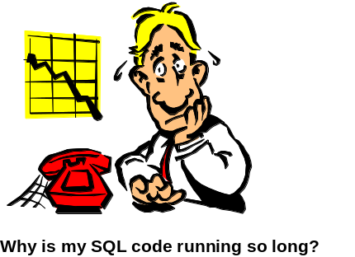

Use a single SQL statement rather than multiple statements whenever
possible.

BAD:

UPDATE emp
set ename = ‘MOE’
where empno = 3;

UPDATE emp
set sal = 4000
where empno = 3;

GOOD:

UPDATE emp
set ename = ‘MOE’, SAL = 4000
where empno = 3;

BAD:

SELECT * FROM EMP WHERE DEPTNO = 10;
SELECT * FROM EMP WHERE DEPTNO = 20;
SELECT * FROM EMP WHERE DEPTNO = 30;

GOOD:

SELECT * FROM EMP WHERE DEPTNO IN (10,20,30);

USING HINTS TO CONTROL THE DRIVING TABLE


Listed below are two methods of sending hints to the ORACLE
optimizer:

Method 1: (Recommended)

ORACLE> SELECT /*+ ORDERED */ ENAME,LOC
FROM EMP, DEPT
WHERE EMP.DEPTNO = DEPT.DEPTNO;
/* EMP IS THE DRIVING TABLE */
Method 2:

ORACLE> SELECT /*+ USE_NL(DEPT,EMP) */ ENAME, LOC
FROM DEPT, EMP
WHERE EMP.DEPTNO = DEPT.DEPTNO;
-- DEPT IS THE DRIVING TABLE

HINTS:

• FULL • ROWID • CLUSTER
• HASH • INDEX • INDEX
• INDEX_ASC • INDEX_DESC • INDEX_MERGE
• ORDERED • USE_MERGE • USE_NL

Lab 9- using the optimizer and explain plan



Create the BIG and BIG2 tables and indexes using the script big1.sql and big2.sql
Scripts. Given a non-unique index BIG_BIGNO on the BIGNO column of BIG, and a non-unique index BIG_BNAME on the BNAME column of the BIG table, use EXPLAIN PLAN to determine how ORACLE would process the following utilizing ALL_ROWS and FIRST_ROWS.
EXPLAIN PLAN FOR
1. ORACLE> Select * from big where bigno > 1;
SELECT * FROM TABLE(dbms_xplan.display

HINT: use AUTOTRACE to help provide the information.

ORACLE> delete from plan_table;
2. ORACLE> explain plan for
Select * from BIG where bname like ‘BET%’;
SQL> select * from table (dbms_xplan.display)

3. Using the Optimization type of FIRST_ROWS then ALL_ROWS do:
ORACLE> delete from plan_table;

ORACLE> explain plan for Select MAX(BIGNO) from big;
SELECT * FROM TABLE(dbms_xplan.display

4. Using the Optimization type of ALL_ROWS then FIRST_ROWS do:
ORACLE> delete from plan_table;
ORACLE> explain plan for
Select * from big where bigno IN (500, 99500);
SELECT * FROM TABLE(dbms_xplan.display

5. Using the Optimization type of ALL_ROWS and FIRST_ROWS_1000 do:
ORACLE> delete from plan_table;

ORACLE> SELECT * FROM BIG WHERE BIGNO = 1000 AND
BNAME = ‘ONE THOUSAND’;
SELECT * FROM TABLE(dbms_xplan.display

Lab 9- continued

Given non-unique indexes on all columns of the BIG2 table plus a
concatenated non-unique index on the BNAME and BIGNO columns
of the BIG2 table, use EXPLAIN PLAN to determine how ORACLE would
execute the following queries:

6. Using the Optimization type of ALL_ROWS and FIRST_ROWS do:
ORACLE> delete from plan_table;

ORACLE> Select bigno from big2 where bname = ‘ONE THOUSAND’;
SELECT * FROM TABLE(dbms_xplan.display

7. Using the Optimization type of ALL_ROWS do:
ORACLE> SELECT * FROM TABLE(dbms_xplan.display

ORACLE> select bigno, bname from big2
where lower(BNAME) = ‘one thousand’;

8. Using the Optimization type of ALL_ROWS do:
ORACLE> delete from plan_table;

ORACLE> select bigno, bname
from big2
where bname = ‘ ONE THOUSAND’ and bigno = 1;

9. Using the Optimization type of ALL_ROWS and FIRST_ROWS do:
ORACLE> delete from plan_table;

ORACLE> select big.bigno, big2.bname
from big, big2
where big.bigno = ABS(big2.bigno + 0);

( THE DRIVING TABLE IS: _______________________)

10. Using the Optimization type of ALL_ROWS do:
ORACLE> delete from plan_table;

ORACLE> select big.bigno, big2.bnam
from big, big2
where ABS(big.bigno) + 0 = big2.bigno;

(THE DRIVING TABLE IS: ___________________)

11. The following exercise will have you alter you session setting the optimizer
to the type of ALL_ROWS and than perform a series of EXPLAIN PLANs
for the same SQL statement except for the value being searched. The main
purpose of this is to demonstrate when it is more efficient for ORACLE to
perform a full table scan versus using an Index on the BIGNO column.
For each of these queries identify the
Cost Table Access %Rows Returned

1. ORACLE> Use the ALL_ROWS Hint;
ORACLE> delete from plan_table;

2. ORACLE> SELECT * FROM BIG
WHERE BIGNO > 2999999;

3. ORACLE> SELECT * FROM BIG
WHERE BIGNO > 2995000;
ORACLE> delete from plan_table;

4. ORACLE> SELECT * FROM BIG
WHERE BIGNO > 2980000;
ORACLE> delete from plan_table;

5. ORACLE> SELECT * FROM BIG
WHERE BIGNO > 2971000;
ORACLE> delete from plan_table;

6. ORACLE> SELECT * FROM BIG
WHERE BIGNO > 2960161;

ORACLE> delete from plan_table;

7. ORACLE> SELECT * FROM BIG
WHERE BIGNO > ?????;
(Where ????? identifies the point at which ORACLE
uses a FULL TABLE SCAN)

PERFORMANCE DIAGNOSTIC TOOLS

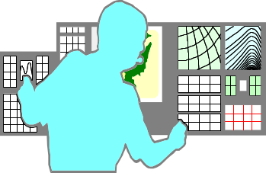

• Explain Plan

The actual SQL statement IS NOT executed. Instead, a plan tree is
inserted into the PLAN_TABLE. You must run a query on the
PLAN_TABLE

• SQL Trace Facility

SQL statement is executed. Use this facility for very long-running
queries. This facility records statistics for each SQL statement in a
single session, storing statistics in a file with an extension of .trc
(Trace Dump File). These statistics are to the nearest second for the
PARSE, EXECUTE, and FETCH phase of each SQL statement.

• TKPROF (Trace Kernel Profile)

Submit a trace dump file (.trc) as input to the TKPROF facility. this
facility formats a report, and stores it on the disk with an extension
of .prf unless you specify your own extension.

SQL Trace Utility

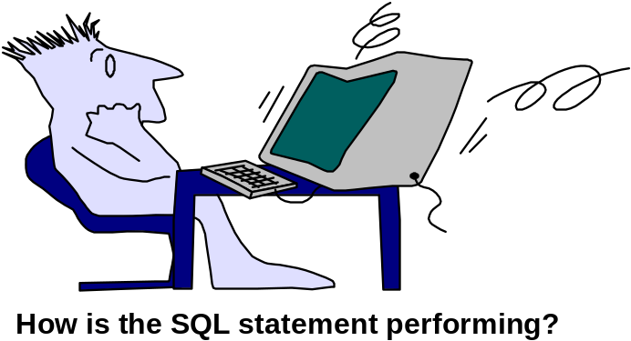

The SQL Trace Utility provides performance information on each SQL statement.
It tracks the following statistics:

• - Parse, execute, fetch counts
• - CPU Times & elapsed times
• - Physical & logical reads
• - Number of rows processed

SQL Trace utility is enabled by using INIT.ORA parameters:

• TIMED_STATISTICS=TRUE turns on CPU timings to the nearest
second
• TRACE_ENABLED=TRUE to use dump files
• MAX_DUMP_FILE_SIZE=no_blocks file output for trace
• USER_DUMP_DEST=default_directory for dumps
• SQL_TRACE=FALSE (default)
=TRUE (SQL trace facility for every SQL statement)

To activate SQL trace for a single session, enter the following command:

ORACLE> ALTER SESSION SET SQL_TRACE = TRUE;

ORACLE> ALTER SESSION SET SQL_TRACE=FALSE;

TKPROF (Trace Kernel Profile)



TKPROF translates a trace file into readable format, and can also generate Explain
Plan output. Typing TKPROF by itself will give you a on-line help list. This command is executed from a UNIX or DOS prompt.

% or c:orant/bin> TKPROF

TKPROF SYNTAX:

%TKPROF trace_file output_file [ SORT= sort option1...] print = n
EXPLAIN=userid/password

• trace_file is the input trace file

• output_file is the output file TKPROF has formatted

• SORT sorts the statistics in the output file in sorted order
Some sort options are
-PRSCNT Count of times parsed
-PRSCPU Count time during parsing
-PRSPHR Physical reads during parsing
-EXECPUT CPU time during execution
-EXEPHR Physical reads during execution
-FCHPHR Physical reads during fetch

• PRINT=n output the first n analyzed statements

• EXPLAIN run the EXPLAIN PLAN statement on all of the SQL
statements in the trace. Create a Plan table and delete it when
finished.

USING TKPROF

1. To use TKPROF, ensure that your session has the SQL Trace Utility set to
true:

ORACLE> ALTER SESSION SET SQL_TRACE TRUE;

2. Identify where the .trc file is. You can identify the user dump file and where it
was sent to and if SQL TRACE is TRUE by executing the following script:

ORACLE> select name,value from V$PARAMETER
where NAME = ‘user_dump_dest’;

NAME VALUE
------------------------------------------ -------------------------------------------------------------
timed_statistics TRUE
user_dump_dest /u01/app/oracle/admin/orcl/udump

3. Execute a sql script which will generate the Trace file with the appropriate
statistics.

ORACLE> SELECT * FROM BIG
WHERE BIGNO = 5000;

4. ALTER SESSION SET SQL_TRACE=FALSE;

5. Go to the user_dump_dest and identify the .trc file by looking at the date and
time it was created. You can use File Manager for this if necessary.

6. Execute TKPROF on the appropriate .trc file.
UNIX
%tkprof %ORACLE_HOME%\rdbms\admin\log\ora_1914.trc mytrace

C:\oracle\product\19.3.0\db_1\BIN\tkprof c:\oracle\rdbms\trace\ora_1914.trc mytrace

7. Browse the mytrace.prf file created from tkprof in your “CURRENT” directory.

c:\oracle\product\11.2.0\db_1\BIN> edit mytrace.prf

TKPROF COLUMN DEFINITIONS

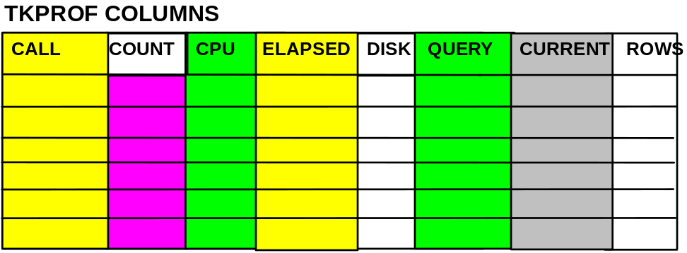

CALL - Parse, Execute, or Fetch
COUNT - Number of times a statement was parsed, executed, or fetched.
Multiple data blocks may be read by each fetch call.
CPU - Total CPU time in seconds for all parse, execute, or fetch calls
for the statement
ELAPSED - Total elapsed time in seconds for all parse, execute, or fetch
calls for the statement
DISK - Total number of data blocks physically read from the data files
on disk for all parse, execute, or fetch calls
QUERY - Total number of buffers retrieved in consistent mode for all
parse, execute, or fetch calls
CURRENT - Total number of buffers retrieved in current mode. Buffers are
often retrieved in current mode for insert, update, and delete
statements
ROWS - Total number of rows processed by the SQL statement. The
total does not include rows processed by subqueries.

NOTE: For select statements, the number of rows returned appears for the fetch
step. For delete, insert, and update statements, the number of rows
processed appears for the execute step.

Execute phase is concerned with INSERTS, UPDATES & DELETES

Fetch phase is concerned with SELECTs

SAMPLE TKPROF REPORT

C:\$ORACLE_HOME\ADMIN\ORCL\TRACE> EDIT mytrace.prf

select *
from staff where id > 50

call count cpu elapsed disk query current rows
-------- ------- -------- --------- -------- -------- ------- ----------
Parse 1 0.09 0.23 6 25 1 0
Execute 1 0.00 0.00 0 0 0 0
Fetch 3 0.01 0.01 1 3 3 40

-------- ------- -------- --------- -------- -------- ------- ----------
total 5 0.10 0.24 7 28 4 40

Misses in library cache during parse: 1
Optimizer hint: CHOOSE
Parsing user id: 5

OVERALL TOTALS FOR ALL NON-RECURSIVE STATEMENTS

call count cpu elapsed disk query current rows
-------- ------- -------- --------- -------- -------- ------- ----------
Parse 3 0.09 0.23 6 25 1 0
Execute 4 0.00 0.14 0 6 0 0
Fetch 5 0.01 0.01 1 3 3 48

Misses in library cache during parse: 1
Misses in library cache during execute: 1

4 user SQL statements in session.
5 internal SQL statements in session.
10 SQL statements in session.
******************************************************************************
Processed trace file: ora_1941.trc
1 session in tracefile.
4 user SQL statements in tracefile.
6 internal SQL statements in tracefile.
10 SQL statements in tracefile.
9 unique SQL statements in tracefile.
109 lines in trace file.

Lab 5 - using sql trace and tkprof

Using SQL Trace Utility and TKPROF, compare the following queries to
see which one appears to be the fastest:

1. ORACLE> SELECT BIG.BNAME, BIG2.BIGNO
FROM BIG, BIG2
WHERE BIG.BIGNO = BIG2.BIGNO AND
BIG2.BNAME = ‘ONE THOUSAND’;

2. ORACLE> SELECT BIG.BNAME
FROM BIG
WHERE BIGNO IN (SELECT BIGNO FROM
BIG2
WHERE BNAME = ‘ONE THOUSAND’);

3. ORACLE> SELECT BIG.BNAME
FROM BIG
WHERE 0 < (SELECT COUNT(*)
FROM BIG2
WHERE BIG2.BNAME = ‘ONE THOUSAND’
AND BIG.BIGNO = BIG2.BIGNO);

Lab 5 - using sql trace and tkprof (CONTINUED)

4. Fill in the formatted report from TKPROF for the first SQL statement:

$tkprof $ORACLE_BASE/diag/rdbms/trace/ora______.trc lab84
explain=userid/password

lab84.prf
*********************************************************************************************
select big.bname, big2.bigno
from big, big2
where big.bigno = big2.bigno
and big2.bname = ‘ONE THOUSAND’;

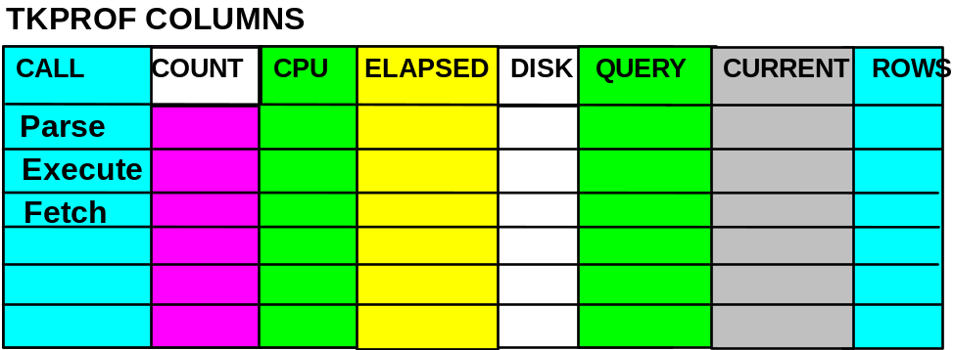

Misses in library cache during parse: _______________
Parsing user id: ______userid __________

ROWS EXECUTION PLAN

Lab 5 - using sql trace and tkprof (CONTINUED)

5. Fill in the formatted report from TKPROF for the first SQL statement:

$tkprof /$ORACLE_BASE/diag/rdbms/fenago/fenago/trace/ora______.trc lab84
explain=userid/password

lab84.prf
*********************************************************************************************
select big.bname,
from big
where BIGNO IN (SELECT BIGNO
FROM BIG2
WHERE BNAME = ‘ONE THOUSAND’);

Misses in library cache during parse: _______________
Parsing user id: ______userid __________

ROWS EXECUTION PLAN

Lab 5 - using sql trace and tkprof (CONTINUED)

6. Fill in the formatted report from TKPROF for the first SQL statement:

c:\tkprof c:\$ORACLE_HOME\rdbms\admin\orcl\udump\ora______.trc lab84
explain=userid/password

lab84.prf
*********************************************************************************************
select big.bname
from big
where 0 < (SELECT COUNT(*)
FROM BIG2
WHERE big2.bname = ‘ONE THOUSAND’
AND BIG.BIGNO = BIG2.BIGNO);

Misses in library cache during parse: _______________
Parsing user id: ______userid __________

ROWS EXECUTION PLAN

This page left blank intentionally

